Today’s testing focused on the Abiogenix swab design with a nubbed tip (https://github.com/HMS-RIC/Covid19-NP-Swab/tree/master/design_files/abiogenix_swab_nubs), modified and printed in PA11 by HP, and also standardizing test methods (updated in https://github.com/HMS-RIC/Covid19-NP-Swab/blob/master/Testing/Testing%20Procedures.md).

For comparison I also used the same design printed in a proprietary epoxy on an SLA printer (this is not one of the official materials under consideration), and a Copan NP swab. Swabs were done by a doctor who has been doing shifts at a drive-through test site and grabbed a couple extra swabs on her way over.

Test 1, clinical evaluation:

* The SLA part is the stiffest, followed by Copan, then PA11. All were flexible but strong enough to maneuver through narrow passages (push through a lightly closed fist) and none felt too fragile. The tip was rough when jabbed into the back of the hand but not painful.
* The flocking was nice and soft on fingertips and was nicer in the lower nostril but I couldn’t tell a difference higher up.
* Doing the NP swabs on the doctor (person A) and me, both of us had one fairly blocked nostril and one clear one. There didn’t seem to be much of a difference in being able to get to the NP between the different swabs. For me all three caused a burning/stinging sensation once they were past the nasal cavity but none felt worse than the others. The general sensation and overall experience was unpleasant enough that I didn’t notice any difference between the Copan flocked tip and the others. Person A didn’t get a Copan swab but said both printed parts were acceptable to use and to have the test done.
* Snapping off – she’s been actually putting the VTM vial in a holder in front of her and grabbing the swabs with both hands on either side of the break point to snap it in two. That was easy for both printed parts. I snapped them off against a 15ml falcon tube, worked perfectly on the first try for both parts.

Test 2, sample collection

* All swabs came out wetted, most with some visible mucus between the rows of nubs. Rotating against the NP seems to have ‘spooled’ strands of mucus around the swab, captured between nubs (couldn’t get an in-focus picture of this). Swiping the 3D printed designs against a slide didn’t visibly leave much behind, sometimes just an array of dots as the nubs contacted while rolling the swab tip against the slide. The 3D printed swab smears only covered ~5-20% of the slide area covered by a smear from a cotton swab or the Copan swab (almost continuous coverage)
* To try and pull more material off the swab for staining we tried putting a drop of buffer (used EPA water but saline or PBS would work) then rolling the swab back and forth through the liquid.
* Results!
  + Don’t have a great way to count cells and field of view isn’t big enough to get a great idea of density so at the end are links to videos of panning over the various slides, all at the same magnification. Note I’m currently getting over a sinus infection and my samples are completely full of grossness even though I wasn’t that mucus-y. Conclusions below if you don’t have time to watch the videos.
  + More material was visibly transferred to the slide from the direct (no extra buffer) smear, probably because the mucus stuck directly to the dry slide but not as well to a wet slide. Staining showed plenty of bacteria in the mucus steaks for both methods, but loose cells/bacteria were much more common in the samples smeared with buffer.

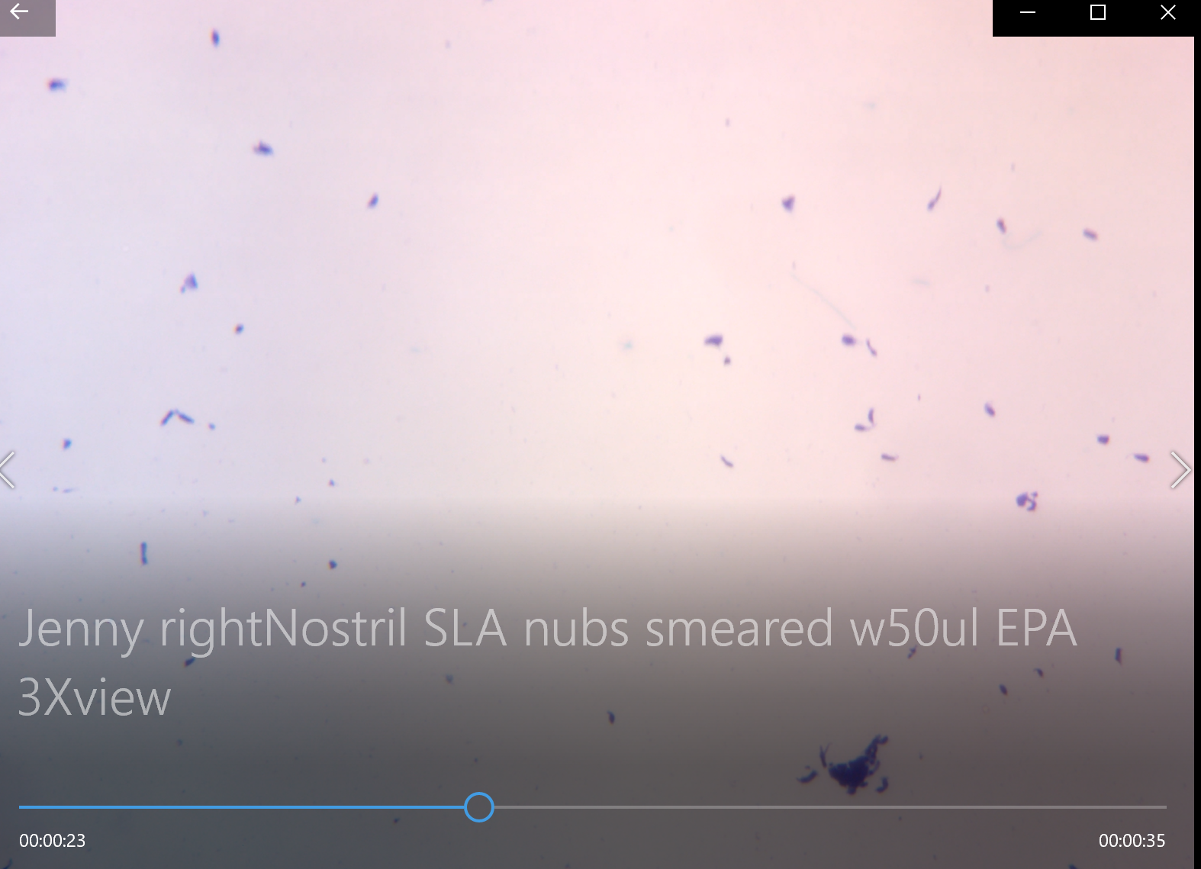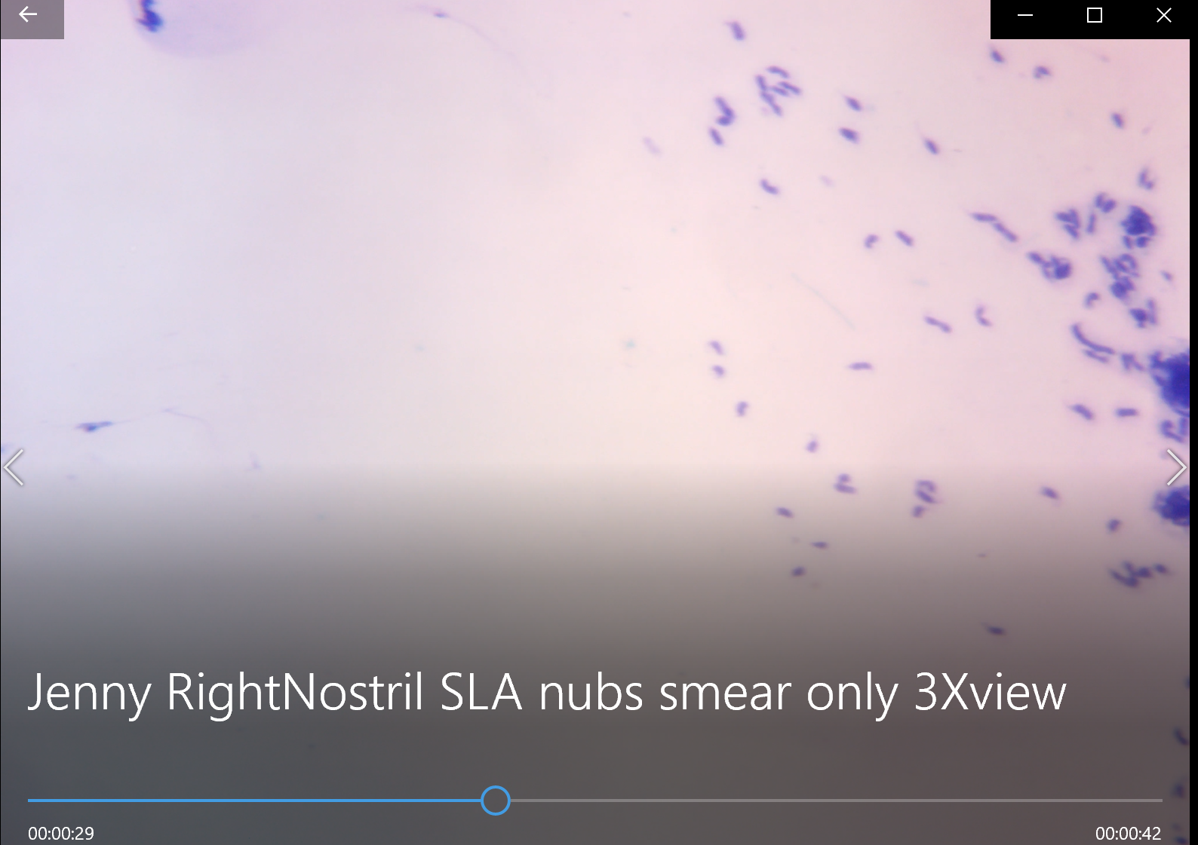

* My conclusions:
  + if the swab comes out coated with a visible amount of wet sample either filling/inside the swab or sitting on the swab (not fully absorbed inside), it has cells/bacteria inside that fluid and has probably picked up enough sample to be useable for PCR. See <https://www.dropbox.com/s/wlb316jv5kuow6q/IMG_20200323_193553%5B1%5D.jpg?dl=0> , if you zoom in you can see mucus between the nubs and fluid filling in the rest of the volume of the tip.
  + If the swab has enough fluid/mucus sticking out from the tip to leave a smear on the slide, that will give a representative idea of what cells/bacteria are being picked up. If the swab looks “dry” or after attempting to smear no material is visibly left on the slide then I would recommend rolling it in a drop (50ul worked well for the methylene blue assay, gram stain may be different) of fluid on the slide to help wash material off of the swab to make sure material isn’t just ‘trapped’ inside the swab geometry in a way that could elute but won’t smear well. Video of this method here: https://www.dropbox.com/s/coizu1qvzxpvwau/cheek%20swab%26stain%20w%20methylene%20blue%20for%20spiky%20swabs%20using%2050ul%20buffer%20to%20wet%20swab.mp4?dl=0
  + The 3D printed swabs are definitely yielding less than the Coban swab, but with the quick staining method we really can’t tell how much of that is due to sample collection vs sample transfer to the slide. I’ll follow up with Dr. Ray Monnet at UW who suggested doing a study of sample collection efficiency (using a controlled viral stock solution) from our various swabs vs commercial but don’t think that should block us from moving forward for now – it would just be a useful data point on the expected relative sensitivity of the 3d printed vs manufactured swabs when viral counts are low.
  + Updated the testing page (<https://github.com/HMS-RIC/Covid19-NP-Swab/blob/master/Testing/Testing%20Procedures.md>) with a method to compare the absorbancy of different swabs with fairly available tools, but the swab+stain test sems the most relevant, so maybe it’s worth just finding nearby microbiology labs who can help with that work. I mixed up the methylene blue in ~15 minutes and each sample takes 5-10 minutes to swab, stain, image.

Test 3: PCR

* Gave samples of the HP PA11 material to UW virology for testing. A friend will autoclave more PA11 samples tomorrow and if both those tests pass we’ll also PCR the autoclaved samples to make sure the high temps don’t damage the plastic in a way that affects the reaction. Should also have PA12 samples in hand for PCR test tomorrow.

My overall conclusions from tests 1-2. I think we can make a completely (non-flocked) 3D printed part that is clinician/patient acceptable and while less effective than the Coban swab, in most cases collects enough sample for a positive ID. From my sample size of 2 (my friend and the medical assistant who swabbed me for my real test last week) the people who are going to be doing high throughput swabbing don’t have a ton of training on this and aren’t going to be too picky, and from their point of view patients are super grateful to be getting the test and can tolerate the brief discomfort/even slight pain. So we should put effort towards not making this a torture device but don’t need to optimize too much here for the first short term “fill the immediate gap” run.